CHAPTER 1

**INTRODUCTION**

Cervical cancer growth in women is a standout amongst the most widely recognized tumors around the world, next just to bosom disease. Moderately aged ladies between the ages of 40-55 years are for the most part influenced by this malignancy. Consistently cervical is analyzed in around 500,000 ladies comprehensively and is in charge of in excess of 280,000 deaths yearly. These days there is a wide variety in the quantity of cervical malignancy cases over the globe. Hazard factors incorporate smoking, unprotected sex or having HIV disease, delayed utilization of anti-conception medication pills. In the western side, pervasiveness of this illness is steadily diminishing a result of the early identification through customary screening. 80% of the new cervical malignant growth cases happen in creating nations, similar to India, which reports around 1/4th of the world's instances of cervical disease every year.

The National Cancer Control Program (NCCP) formulated and funded by the Ministry of Health, Government of India has stressed upon the implementation of community based cervical screening program at least in select districts of each state. The NCCP has made provision for fund to be given to all the states to implement the cancer control program that includes cervical cancer screening activities.

Cervical cancer occurs when abnormal cells in the cervix multiply at a faster rate and grow out-of-control. The abnormal changes that the cervical cells develop transform them to a precancerous state which is referred to as ‘Cervical Intraepithelial Neoplasia’ (CIN). Based on its degree or intensity, these changes are classified as low grade CIN and high grade CIN. This cancer is caused by a virus called Human Papilloma Virus (HPV).

Two popular screening tests which help in the early detection of cervical cancer or prevent cervical cancer are: (i) Pap test (or Pap smear)-looks for pre-cancer cell changes on the cervix. (ii) HPV test- looks for the HPV virus that causes the cell change. Another popular screening method is the Liquid Based Cytology (LBC). LBC is a way of preparing cervical samples for examination and diagnosis in the laboratory. Detection rate is higher using LBC than Pap test. All these processes are proved to be time consuming and might yield erroneous results. This paper presents an efficient and proficient method for the diagnosis of cervical cancer using Image Processing of cytology images.

## 1.1 Aim

Our project “Detection of Cervical Cancer using Image Processing” aims at —

**"To develop an automated system that enables proficient and effective detection of Cervical Cancer”.**

## 1.2 Problem Definition

Cervical Cancer is one of the most common cancers among women worldwide. The proposed system will reduce the workload on clinicians and makes the diagnosis of cancer faster, economical, and more accurate by making use of image processing techniques of

MATLAB.

## 1.3 Objectives

Following are the objectives which are monitored and accomplished in this work:

1. To develop an automated system that enable proficient and effective detection of Cervical Cancer that can be implemented for commercial purpose.
2. Making use of image processing toolboxes of MATLAB
3. Pathologists can use this method as a decision support in detecting cancer. This will reduce the workload on clinicians and makes the diagnosis of cancer faster, economical and more accurate.

Different features explored in various works are considered along with new significant features in this work and extracted to increase the efficiency of Cancer diagnosis system.

## 1.4 Motivation

Cervical cancer is the second occurring cancer in women of all age group. This cancer does not have any symptoms and cannot be detected at the early stage. The main problem with this cancer is that it cannot be detected as it doesn’t throw any symptoms until the final stages. This is attributed to the cancer itself and conjointly to the shortage of pathologists obtainable to screen the cancer. Motivations for cervical cancer screening includes the need for comprehensive assessment, diagnosis, and management of all ailments to ensure good health, fear of consequences of cervical cancer, suspicion of being in danger and also the want to take care of an honest relationship with health care employees. Major barriers to repeat screening includes limited knowledge and appreciation of the need for repeat screening, and lack of reminders.

## 1.5 Applications

Automatic Detection of Cervical Cancer can be used in the hospitals and diagnosis centers whenever the detection of cervical cancer is required. Our application would help various pathologists and clinicians.

## 1.6 Advantages

**Ease of use:** Provides a user-friendly and an interactive interface facilitating ease of use.

**Generic:** The application can be run on any computer currently available in the hospitals and diagnostic centres.

**Flexible:** Users can access the features provided by the application anywhere and anytime with the help of a computer.

## 1.7 Background

Cervical cancer occurs when abnormal cells in the cervix multiply at a faster rate and grow out-of-control. The abnormal changes that the cervical cells develop transform them to a pre-cancerous state which is referred to as ‘Cervical Intraepithelial Neoplasia’ (CIN). Based on its degree or intensity, these changes are classified as low grade CIN and high grade CIN. This cancer is caused by a virus called Human Papilloma Virus (HPV).

[Human](https://en.wikipedia.org/wiki/Human_papillomavirus_infection) [papilloma virus infection](https://en.wikipedia.org/wiki/Human_papillomavirus_infection) (HPV) causes more than 90% of cases; most people who have had HPV infections, however, do not develop cervical cancer. Other risk factors include [smoking,](https://en.wikipedia.org/wiki/Smoking) a [weak immune system](https://en.wikipedia.org/wiki/Immunodeficiency) [,](https://en.wikipedia.org/wiki/Immunodeficiency)[birth control pills,](https://en.wikipedia.org/wiki/Oral_contraceptive_pill) starting sex at a young age, and having many sexual partners, but these are less important. Cervical cancer typically develops from [precancerous changes](https://en.wikipedia.org/wiki/Precancerous_condition) over 10 to 20 years. About 90% of cervical cancer cases are [squamous cell carcinomas,](https://en.wikipedia.org/wiki/Squamous_cell_carcinoma) 10% are [adenocarcinoma,](https://en.wikipedia.org/wiki/Adenocarcinoma) and a small number are other types. Diagnosis is typically by [cervical screening](https://en.wikipedia.org/wiki/Cervical_screening) followed by a[biopsy.](https://en.wikipedia.org/wiki/Biopsy) [Medical imaging](https://en.wikipedia.org/wiki/Medical_imaging) is then done to determine whether or not the cancer has spread.

[HPV vaccines](https://en.wikipedia.org/wiki/HPV_vaccines) protect against between two and seven high-risk strains of this family of [viruses](https://en.wikipedia.org/wiki/Virus) and may prevent up to 90% of cervical cancers. As a risk of cancer still exists, guidelines recommend continuing regular tests. Cervical cancer screening using the Pap test or [acetic acid](https://en.wikipedia.org/wiki/Acetic_acid) can identify precancerous changes which when treated can prevent the development of cancer. Treatment of cervical cancer may consist of some combination of [surgery,](https://en.wikipedia.org/wiki/Surgery) [chemo therapy,](https://en.wikipedia.org/wiki/Chemotherapy) and [radiation therapy.](https://en.wikipedia.org/wiki/Radiation_therapy) [Five-year survival rate in](https://en.wikipedia.org/wiki/Five-year_survival_rate) the United States are 68%.Outcomes, however, depend very much on how early the cancer is detected.

### 1.7.1 Cell Types

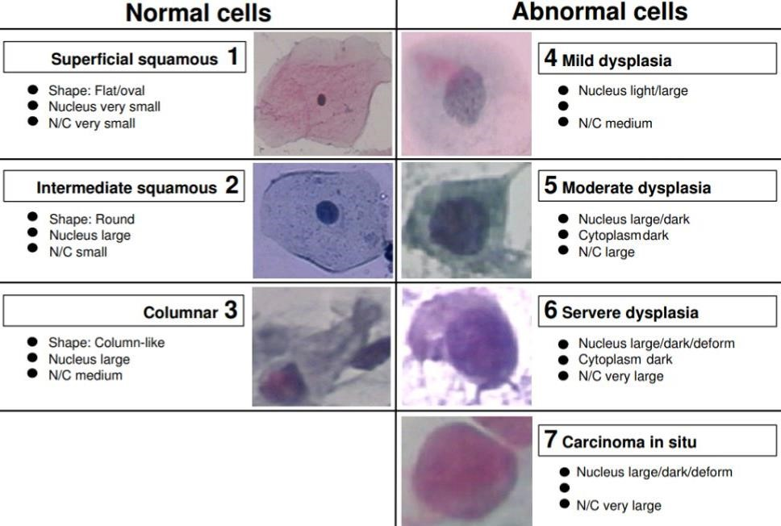

#### 1.7.1.1. Superficial squamous cell

Superficial squamous cells are large (c. 1600 um^2) polygonal cells with a centrally located small, round, opaque (pyknotic) nucleus measuring about 20 um^2. The cytoplasm is rather bright, sharply demarcated and stains red (eosiniphilia or acidophilia) in an optimally prepared PAP smear. The superficial cells are dying cells, undergoing degeneration, hence the pyknotic nuclei.

The many layers of the squamous epithelium offer a good protection of the underlying tissue. In some circumstances the superficial layers of the squamous epithelium become keratinized, thus offering even better protection of the underlying tissue. The squamous epithelium of the cervix does not normally keratinize. When keratinisation is present, large polygonal squamous cells without nuclei (anuclear cells) can be encountered. The cytoplasm of anuclear squamous cells is stained intensely red or orange (orangeophilia). In addition, in keratinization, superficial cells with small brown granules (hyalokeratin = keratin precursors) may be present. To differentiate a superficial squamous cell from an intermediate squamous cell, one has to study the nuclei. As described, the intermediate nucleus is vesicular and c.35 um^2 whereas the superficial nucleus is pyknotic and measures about 20 um^2.

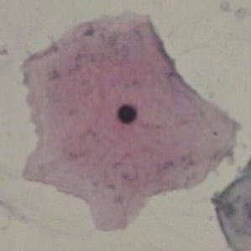

Fig.1.7.1.1. Superficial squamous cell.

#### 1.7.1.2. Intermediate squamous cell

Intermediate squamous cells are large (800-1200 um^2) polygonal (with many straight sides) cells with a centrally located vesicular nucleus measuring about 35um^2. The sizes of the cells vary depending on their location in the epithelium, whereas the size of the nucleus is rather constant. The cytoplasm is light blue/blue-green in an optimally stained PAP-smear.

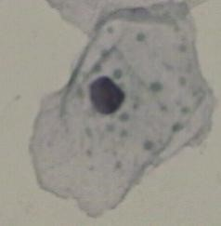

Fig.1.7.1.2.Intermediate squamous cell.

#### 1.7.1.3. Endocervical epithelium

In uterus, including the cervical canal and the uterine cavity, columnar epithelial cells (also known as glandular cells) cover the inner surface. Endocervical cells (from the cervical canal) are almost always found in PAP smears, whereas cells from the uterine cavity (endometrial cells) are found more rarely in smears. Endocervical cells often occur in groups as honeycombs. When present singly, the cells are cylindrical when seen from the side and round when seen from above. Endocervical cells measure about 180 um^2 and have a cytoplasm that is cyanophilic and translucent or vacuolated. The nuclei are round to oval, often very eccentrically placed and measure about 50 um^2. They are vesicular with finely distributed chromatin, and stain more dark blue than the cytoplasm. The cells, that only very little in size during the menstrual cycle, may exhibit cilia.

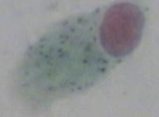

Fig.1.7.1.3.Endocervical epithelium.

#### 1.7.1.4. Mild dysplasia

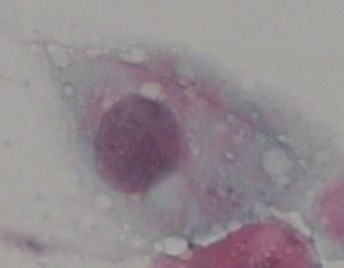The cells are huge about 1000-1500um^2 and polygonal, and only a few round or oval. The cytoplasm is mostly basophilic (in 4 out of 5 samples) and eosinophilic in the other cases. The cytoplasm is light, generous and see-through. The nuclei / cytoplasm ratio is low around 14%. The nucleus is rather big, around 175um^2 in average and round or oval. There are no hyper chromasia and the chromatin is finely regular and granular. The definition of mild, moderate and severe depends on the smear as a single unit, because the diagnose is made from how many dysplasia cells there are in the sample.

Fig.1.7.1.4. Mild dysplasia.

#### 1.7.1.5. Carcinoma in situ

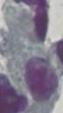Carcinoma in situ has an enlarged nucleus, about 3-5 times the normal nuclei and is round or oval. Hyper chromasia is more distinct than with the dysplasia. The chromatin pattern is irregularly coarsely granular compared to the dysplasia and the nucleus cytoplasm ratio is so big, that the nuclei fill the cell. The cell size very between 95um^2 and 450um^2, and is round or oval. The cytoplasm is sparse and basophilic (blue).

Fig.1.7.1.5. Carcinoma in situ.

### 1.7.2 Causes

### 1.7.2.1. Smoking

Cigarette smoking, both active and passive, increases the risk of cervical cancer. Among HPV-infected women, current and former smokers have roughly two to three times the incidence of invasive cancer. Passive smoking is also associated with increased risk, but to a lesser extent. Smoking has also been linked to the development of cervical cancer. Smoking can increase the risk in women a few different ways, which can be by direct and indirect methods of inducing cervical cancer. A direct way of contracting this cancer is a smoker has a higher chance of [CIN3](https://en.wikipedia.org/wiki/Cervical_intraepithelial_neoplasia) occurring which has the potential of forming cervical cancer. When CIN3 lesions lead to cancer, most of them have the assistance of the HPV virus, but that is not always the case, which is why it can be considered a direct link to cervical cancer. Heavy smoking and long-term smoking seem to have more of a risk of getting the CIN3 lesions than lighter smoking or not smoking at all. Although smoking has been linked to cervical cancer, it aids in the development of HPV which is the leading cause of this type of cancer. Also, not only does it aid in the development of HPV, but also if the woman is already HPV-positive, she is at an even greater likelihood of contracting cervical cancer.

#### 1.7.2.2. Oral contraceptives

Long-term use of oral contraceptives is associated with increased risk of cervical cancer. Women who have used oral contraceptives for 5 to 9 years have about three times the incidence of invasive cancer, and those who used them for 10 years or longer have about four times the risk.

#### 1.7.2.3. Multiple pregnancies

Having many pregnancies is associated with an increased risk of cervical cancer. Among HPV-infected women, those who have had seven or more full-term pregnancies have around four times the risk of cancer compared with women with no pregnancies, and two to three times the risk of women who have had one or two full-term pregnancies.

### 1.7.3 Treatment

The treatment of cervical cancer varies worldwide, largely due to access to surgeons skilled in radical pelvic surgery, and the emergence of fertility-sparing therapy in developed nations. Because cervical cancers are radiosensitive, radiation may be used in all stages where surgical options do not exist. Surgical intervention may have better outcomes than radiological approaches. In addition, chemotherapy can be used to treat cervical cancer, and has been found to be more effective than radiation alone.

Micro invasive cancer (stage IA) may be treated by [hysterectomy](https://en.wikipedia.org/wiki/Hysterectomy) (removal of the whole uterus including part of the [vagina)](https://en.wikipedia.org/wiki/Vagina). For stage IA2, the [lymph nodes](https://en.wikipedia.org/wiki/Lymph_node) are removed, as well. Alternatives include local surgical procedures such as a [loop electrical excision procedure](https://en.wikipedia.org/wiki/Loop_electrical_excision_procedure) or [cone biopsy.](https://en.wikipedia.org/wiki/Cervical_conization)

If a cone biopsy does not produce clear margins findings on biopsy showing that the tumor is surrounded by cancer free tissue, suggesting all of the tumor is removed), one more possible treatment option for women who want to preserve their fertility is a[trachelectomy.](https://en.wikipedia.org/wiki/Trachelectomy) This attempts to surgically remove the cancer while preserving the ovaries and uterus, providing for a more conservative operation than a hysterectomy. It is a viable option for those in stage I cervical cancer which has not spread; however, it is not yet considered a standard of care, as few doctors are skilled in this procedure. Even the most experienced surgeon cannot promise that a trachelectomy can be performed until after surgical microscopic examination, as the extent of the spread of cancer is unknown. If the surgeon is not able to microscopically confirm clear margins of cervical tissue once the woman is under general anesthesia in the operating room, a hysterectomy may still be needed. This can only be done during the same operation if the woman has given prior consent. Due to the possible risk of cancer spread to the lymph nodes in stage 1b cancers and some stage 1a cancers, the surgeon may also need to remove some lymph nodes from around the uterus for pathologic evaluation.

A radical trachelectomy can be performed abdominally or vaginally and opinions are conflicting as to which is better. A radical abdominal trachelectomy with lymphadenectomy usually only requires a two- to three-day hospital stay, and most women recover very quickly (about six weeks). Complications are uncommon, although women who are able to conceive after surgery are susceptible to preterm labor and possible late miscarriage. A wait of at least one year is generally recommended before attempting to become pregnant after surgery. Recurrence in the residual cervix is very rare if the cancer has been cleared with the trachelectomy. Yet, women are recommended to practice vigilant prevention and follow-up care including Pap screenings/ [colpos copy,](https://en.wikipedia.org/wiki/Colposcopy) with biopsies of the remaining lower uterine segment as needed (every 3–4 months for at least 5 years) to monitor for any recurrence in addition to minimizing any new exposures to HPV through [safe sex](https://en.wikipedia.org/wiki/Safe_sex) practices until one is actively trying to conceive.

Early stages (IB1 and IIA less than 4 cm) can be treated with radical hysterectomy with removal of the lymph nodes or [radiation therapy.](https://en.wikipedia.org/wiki/Radiation_therapy) Radiation therapy is given as external beam radiotherapy to the pelvis and [brachy therapy](https://en.wikipedia.org/wiki/Brachytherapy) (internal radiation). Women treated with surgery who have high-risk features found on pathologic examination are given radiation therapy with or without chemotherapy to reduce the risk of relapse.

#### 1.7.3.1. Brachy therapy for cervical cancer

Larger early-stage tumours (IB2 and IIA more than 4 cm) may be treated with radiation therapy and [cisplatin-](https://en.wikipedia.org/wiki/Cisplatin)based chemotherapy, hysterectomy (which then usually requires [adjuvant](https://en.wikipedia.org/wiki/Adjuvant) radiation therapy), or cisplatin chemotherapy followed by hysterectomy. When cisplatin is present, it is thought to be the most active single agent in periodic diseases. Such addition of platinum-based chemotherapy to chemo radiation seems not only to improve survival but also reduces risk of recurrence in women with early stage cervical cancer (IA2-IIA).

Advanced-stage tumours (IIB-IVA) are treated with radiation therapy and cisplatin-based chemotherapy. On June 15, 2006, the US [Food and Drug Administration](https://en.wikipedia.org/wiki/Food_and_Drug_Administration) approved the use of a combination of two chemotherapy drugs, [hycamtin](https://en.wikipedia.org/wiki/Hycamtin)and cisplatin, for women with late-stage (IVB) cervical cancer treatment. Combination treatment has significant risk of [neutropenia,](https://en.wikipedia.org/wiki/Neutropenia)[anaemia,](https://en.wikipedia.org/wiki/Anemia) and [thrombocytopenia](https://en.wikipedia.org/wiki/Thrombocytopenia)side effects.

For surgery to be curative, the entire cancer must be removed with no cancer found at the margins of the removed tissue on examination under a microscope. This procedure is known as exoneration.

**CHAPTER 2**

# LITERATURE SURVEY

A literature review is a written document that presents a logically argued case founded on a comprehensive understanding of the current state of knowledge about a topic of study. This literature review discusses about the work on detection of cervical cancer using image processing and machine learning techniques.

## 2.1 Related work

**Eko Supriyanto** developed a detection system that is able to differentiate between normal and cancerous cells by using colour intensity classification methods for automated extraction of multiple features of cytoplasm and nuclei from cervical cytology images are described (2011). The distinctive differences of colour intensity distributions between normal and cancerous cells have been successfully used to characterize cancerous cells.

**N Sakthi Priya** discussed cervical cancer screening and classification using acoustic shadowing. They proposed a novel approach to classify the various malignancies in cervical images using acoustic shadowing. For classification they have used SVM classifier that would help to classify the stages of the cancer and help the pathologist detect the cancer better. The proposed image has been tested with a set of images and has proved to be efficient (2013).

**G Karthigai Lakshmi and K Krishnaveni** discussed multiple feature extraction from Cervical cytology image by Gaussian mixture model. This method separates nucleus and cytoplasm from both single and multiple cellular Pap smear cervical cytology images using Gaussian mixture model (2014).

**Shipra Roy, R.P Chauhan, G.K. Verman** done a study towards developing an automatic image classification system by classifying Region of Interest (ROI). It is very difficult to identify abnormalities and using just the shape, size and gray-level information of a patient’s cervix.

**SetuGarg, ShabanaUrooj, RituVijay** discussed detection of cervical cancer by using thresholding & watershed segmentation.An efficient and practical algorithm to detect the cervical cancerous area is presented in this paper. Magnetic resonance imaging scans of cervical cancer were acquired and its histogram image is segmented in addition with edge detection for extraction of tumorous area with exact edge and shape. The anatomic functional positioning as well as its effect on other cervix areas are also determined. MRI scans of cervical cancer patient are used and are stored in MATLAB in .jpg format. Images are then converted into a grey scale image based on intensity distribution of pixels in that image. Edge detection is applied on the image to find edges of tumour area. The hybrid segmentation is done on the sampled image i.e. combination of thresholding and watershed segmentation to extract the tumour infected region. The image is then processed using morphological image processing tools to detect the accurate dimensions of the tumour (2015).

**CHAPTER 3**

# SYSTEM ANALYSIS

Analysis involves requirement determination and specification. It is basically establishing the requirements for all system elements and then mapping these requirements to software forms. It should address issues such as: -

* Profile of people who are operating on the system.
* Software on which the application is going to function.
* Existing system problems.

Analysis encompasses requirements gathering at the system level with small amount of toplevel design. The data obtained from the requirement determination phase are documented in Software Requirement Specification (SRS) document. During analysis, a great deal of relatively unstructured data is collected through procedural manuals and through websites. The traditional approach is to organize and convert the data through system flowcharts, which support future developments of the system and simplify communication with users. But the system flowcharts represent the physical system rather than the logical system. Hence, it makes it difficult to distinguish between what happens and how it happens in the system. Because of this drawback it is necessary to have something, which is analogous to the architect's blueprint as a starting point for the design. It is the way of focus on the functions rather than physical implementation.

## 3.1 Hardware Requirements

Processor : Intel core i5 (6th Generation) or higher

RAM : 8GB or higher

Memory : Minimum of 10 GB

## 3.2 Software Requirements

Operating System : Microsoft Windows 7 ultimate or higher

Tool : MATLAB 2017

## 3.3 Existing Systems

### 3.3.1. Pap Smear Test

The very popular method is the Papanicolaou smear (Pap) test where all women should intake this test once in a year. A Papanicolaou smear, also called a Pap test, is a screening procedure for [cervical cancer](https://www.healthline.com/health/cervical-cancer) [.](https://www.healthline.com/health/cervical-cancer)It tests for the presence of metastatic tumour or cancerous cells on the cervix. The [cervix](https://www.healthline.com/human-body-maps/cervix-uteri) is the opening of the [uterus.](https://www.healthline.com/human-body-maps/uterus) The doctor or the physician scrapes a small number of cells from the uterus of the cervix region to find changes in the cervical cell before they change into cancer cells.

### Limitations

* The Pap smear test is very costly and only few experienced cytologists are able to conduct this test which leads to high false positive rates due to human error.
* The low sensitivity, inadequate sample collection, sample preparation error and low possibility of accurate microscopic examination are the major drawbacks associated with Pap smear test.
* The Pap smear test requires huge number of samples to be analysed and diagnosed, which is time consuming.

#### 3.3.2. Liquid-based cytology (LBC) test

The LBC test is a cervical screening test that is done to identify any abnormal changes in the cells of the cervix. The Pap smear test is the traditional test for cervical screening, but in recent times testing using liquid-based cytology or LBC has become more common. The liquid-based cytology (LBC) test used for detecting cervical cancer uses 5% acetic acid in the biopsy of the cervical tissues which changes the Aceto white (AW) region into white colour is a way of diagnosing cervical cancer.

### Limitations

* On LBC slides, cell nuclei often take on a more vesicular, delicate appearance. In addition, the LBC specimen has fewer landmarks than conventional Pap smears to guide the human eye during the screening process and can be more challenging and time consuming per unit area to review. Liquid-based collection methods may cause some epithelial cells to round up and appear smaller.
* The rounding up of the cells will make the nucleus-to-cytoplasmic ratio appear altered in the nucleus.

#### 3.3.3. HPV DNA test

HPV test can find any of the high-risk types of HPV that are most commonly found in cervical cancer. The HPV DNA check involves testing cells collected from the cervix for infection with any of the categories of HPV that area unit possibly to steer to cervical cancer. This test may be a choice for women age 30 and older, or for younger women with an abnormal Pap test. The presence of any of those HPV varieties in a woman for many years can lead to cell changes that ought to be treated in order cervical cancer does not occur. The HPV test is done at the same time as the Pap test by using a small soft brush to gather cervical cells that are sent to the laboratory, or the HPV testing sample is also taken directly from the Pap sample.

#### Limitations

* HPV tests might also be more likely to detect abnormal cell changes that would have returned to normal on their own and never developed into cancer.
* Results may not be available immediately.
* High unit cost.
* Complex laboratory requirements and specimen transport.
* Low specificity in young women leading to over treatment and storage of reagents may be problematic.

## 3.4 Proposed system

Cervical cancer is one of the deadliest cancers known. The main problem with this cancer is that it cannot be detected as it doesn’t possess any symptoms until the final stages. This is attributed to the cancer itself and additionally to the shortage of pathologists obtainable to screen the cancer. This requires a requirement for economical and correct technique that diagnoses cervical cancer without human intervention. The proposed system can detect cervical cancer using image processing techniques. Image processing techniques are used to extract morphological features from cytology images

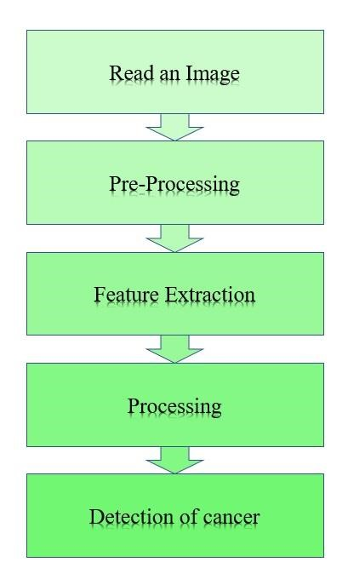

Fig.3.4. Detection of cervical cancerous cells.

**Stage 1: Read an Image**

The first stage involves reading an input RGB image.

### Stage 2: Pre-processing

Pre-processing of an image involves converting RGB image to Grey-level image and smoothening.

**Stage 3: Feature Extraction**

Features are extracted by using canny edge detection algorithm.

### Stage 4 and 5: Processing and Detection of cancerous cells

On extracted features, processing is done using image processing techniques and affected abnormal cells are detected.

## 3.5 Functional and non-functional requirements

### 3.5.1. Functional requirements

In Software engineering and systems engineering, a functional requirement defines a function of a system or its component. A function is described as a set of inputs, the behaviour, and outputs. Functional requirements may be calculations, technical details, data manipulation and processing and other specific functionality that define what a system is supposed to accomplish. Behavioural requirements describing all the cases where the system uses the functional requirements are captured in use cases.

The functional requirements of our system are –

* **Pathologist:** Pathologist are the end users who uses the application to get their results consist of the image which shows whether the one is suffering from the cancer or not.
* The proposed system should be able to diagnose and display the image in the BW colour space.
* It is helpful to detect the affected cells in the sample supplied.

### 3.5.2. Non-functional requirements

In systems engineering and requirements engineering, a non-functional requirement (NFR) is a requirement that specifies criteria that can be used to judge the operation of a system, rather than specific behaviours. They are contrasted with functional requirements that define specific behaviour or functions. The plan for implementing functional requirements is detailed in the system design. The plan for implementing non-functional requirements is detailed in the system architecture, because they are usually Architecturally Significant Requirements. Broadly, functional requirements define what a system is supposed to do and non-functional requirements define how a system is supposed to be. Non-functional requirements are often called "quality attributes" of a system. Other terms for non-functional requirements are "qualities", "quality goals", "quality of service requirements", "constraints" and "non-behavioural requirements”.

The non-functional requirements of our system are:

* **Availability –** System will be available all time. Whenever one can use it.
* **Maintainability –** The system provides a better platform for detecting the affected cells in the sample and make necessary changes in the system, such as selecting new inputs.
* **Reliability –** The system is scalable as it provides the better and faster results.
* **Scalability –** The system is scalable as it allows the pathologist to select the particular image and get the result of it.
* The proposed system should support the end user requirements.
* The system is capable of processing when the large numbers of images are provided as input and also it must be interactive and delays involved should be less. So, in every action-response of the system, there should be no long-term delays.

**CHAPTER 4**

# SYSTEM DESIGN

## 4.1. System Design

System design is the process of defining the architecture, components, modules, interfaces, and data for a system to satisfy the specified requirements. Here, the design functions and operations are described in detail, including screen layouts, business rules, process diagrams and other documentation. The output of this stage will describe the new system as a collection of modules or subsystems. Having a design methodology enforces consistency in the work as it helps in achieving the deadlines timely.

The design stage takes as its initial input the requirements identified in the approved requirements document. For each requirement, a set of one or more design elements will be produced that describe the desired software features in detail. They generally include functional hierarchy diagrams, screen layout diagrams, tables of business rules, business process diagrams, pseudo code, and a complete entity relationship diagram with a full structure of the database.

Systems design implies a systematic approach to the design of a system. It may take a bottom-up or top-down approach, but either way the process is systematic wherein it takes into account all related variables of the system that needs to be created — from the architecture, to the required hardware and software, right down to the data and how it travels and transforms throughout its travel through the system. Systems design then overlaps with systems analysis, systems engineering and systems architecture.

Design begins with requirements model. The team works to transform this model into four level of design detail and they are:

* The data structure
* The system architecture
* The interface representation
* The component level detail

The data design transforms the information domain model created during analysis into the data structure that is required for the implementation. The data objects and relationships defined in the entity relationship diagram and detailed data content depicted provide the basis for the data design activity. Part of data design may occur in conjunction with the design of software architecture.

The importance of software design can be stated with a single word - Quality. Design provides the representations of software that can be assessed for quality. Design is an iterative process through which requirements are translated into a "blueprint" for constructing the software. The design represented at a high level of abstraction - a level that can be directly traced to the specific system objective and more detailed data, functional and behavioural requirements. There are three characteristics that serve as a guide for the evaluation of a good design. Each of these characteristics is actually a goal of the design process. They are:

* The design must implement all of the explicit requirements contained in the analysis model and also accommodate the desired implicit requirements.
* The design must be readable and understandable for coding, testing and subsequently support the software.
* The design should provide a complete picture for addressing the data, functional and behavioural domains from an implementation perspective.

### 4.1.1. Design Process

The design process involves developing several models of the system at different levels of abstraction. As design is decomposed, errors and omissions in earlier stages are discovered. And their feedbacks help in earlier design models to be improved. The various design activities are:

* **Architectural design:** The sub-systems making up the systems and their relationships are identified and documented.
* **Abstract Specification:** For each sub-system an abstract specification of the services it provides and the constraint under which it must be operate is produced.
* **Interface Design:** For each sub-system, its interfaces with other sub-systems is designed and documented. This interface specification must be unambiguous as it allows the subsystem to be used without knowledge of the sub-system operation.
* **Component Design:** Services are allocated to different components and the interfaces of these components are designed.
* **Algorithm Design:** The algorithms are used to provide services that are designed in detail with corresponding specifications.

### 4.1.2. Design Strategies

The two design strategies are:

* **Functional Design:** The system is designed from a functional point of view, starting with high-level view and progressively refining this into a more detailed design. The system state is centralized and shared between the functions of operating on that state.
* **Module Design:** The system is viewed as a collection of modules rather than functions.

## 4.2. System Architecture

System architecture is the conceptual model that defines the structure, behaviour, and more views of a system. An architecture description is a formal description and representation of a system, organised in a way that supports reasoning about the structures and behaviours of the system. A system architecture can comprise system components, the expand systems developed, that will work together to implement the overall system.

Fig

.

4.

2.

Methodology

.

**Input**

**Gray scale**

**Gaussian**

**filter**

**Canny edge**

**detection**

**Bridge and**

**hole filling**

**Grouping**

**affected**

**cells**

**Detection of**

**affected**

**cells**

### 4.2.1. Pre-processing

Firstly, the biological RGB cell image (bitmap image) is converted into grey-scale image. A pre-processing technique is applied to grey-scale image to improve the quality of image and also to eliminate the useless information using Gaussian Filter.

### 4.2.2. Gaussian filter

In a Gaussian filter is rolled over the cytology image to smoothen the region of interest. Filter the image with isotropous Gaussian smoothing kernels of increasing standard deviations. Gaussian filters are isotropic with the same standard deviation along both dimensions. An image can be filtered by an isotropic Gaussian filter by specifying a scalar value for sigma.

### 4.2.3. Canny Edge Detection algorithm

Edge function is used find edges in intensity image. The Canny edge detection is a multi-stage algorithm which is used to detect a wide range of edges in cell images. The Canny edge technique is used to extract the abrupt changes of affected cells and non- affected cells. This technique helps us to make the difference between affected and non affected cells.

#### 4.2.4. Morphological Operations

Morphological functions perform morphological operation on gray-scale image to detect the affected cells.

* **Bridge** bridges previously unconnected pixels in the gray-scale image.
* **Close** performs morphological closing operation (dilation operation followed by erosion)
* **Open** performs morphological closing operation (erosion operation followed by dilation).
* **Erode** performs erosion using the structuring element.
* **Imfill** morphological function fills image regions and holes.
* **Imdilate** morphological function dilates the gray-scale image and returns the dilated image.

#### 4.2.5. Grouping affected cells

Adaptive thresholding is an image segmentation algorithm that appears quite resistant to varying lighting conditions. The most basic thresholding method is to choose a fixed threshold value and compare each pixel to that value.

The affected cells will be retained by using adaptive threshold technique. The maximum intensity values of smoothen image is considered as background.

#### 4.2.6. Extraction of Holes

Where, affected cells forms large sized holes and non-affected cells forms small sized holes. Some of the cells could not generate the holes, at that time bridge morphological function is used to generate the holes.

#### 4.2.7. Extraction of affected cells

Extraction of Affected cells: The larger components are considered as affected cells.

To retain this larger components ,the morphological functions are used effectively.

#### 4.2.8. Jaccard similarity coefficient

The Jaccard similarity (Jaccard 1902, Jaccard 1912) is a common index for binary variables. It is defined as the quotient between the intersection and the union of the pair wise compared variables among two objects.

**Equation:**



In the equation *dJAD* is the Jaccard distance between the objects *i* and *j*. For two data records with *n* binary variables *y* the variable index *k* ranges from 0 to *n*-1. Four different combinations between *yi,k* and *yj,k* can be distinguished when comparing binary variables .These combinations are (0/0), (0/1), (1/0) and (1/1). The sums of these combinations can be grouped by:

* *J01*: the total number of variables being 0 in *yi* and 1 in *yj*.
* *J10*: the total number of variables being 1 in *yi* and 0 in *yj*.
* *J11*: the total number of variables being 1 in both *yi* and *yj*.
* *J00*: the total number of variables being 0 in both *yi* and *yj*.

As each paired variable belongs to one of these groups it can be easily seen that:

*J*00 + *J*01 + *J*10 + *J*11 = *n*

As the Jaccard similarity is based on joint presence, *J*00 is discarded.

The Jaccard dissimilarity is defined as *dJAD* = 1- *dJAS.*

In some cases the Jaccard similarity is computed as *dJAS*=2*dBCD/(*1*+dBCD)*, where *dBCD* is the Bray–Curtis dissimilarity. This equation does not reduce values to binary states. Thus, results are different when using on the one hand a presence/absence matrix and on the other hand a count matrix. The results are the same, when the count matrix is converted to a binary matrix beforehand.

* Statistic used for gauging the similarity and diversity of sample sets.
* Computes the intersection of binary images BW1 and BW2 divided by the union of BW1 and BW2, also known as jaccard index.
* Separates the diseased region from that of undiseased region.
* Computes the jaccard index for each label.

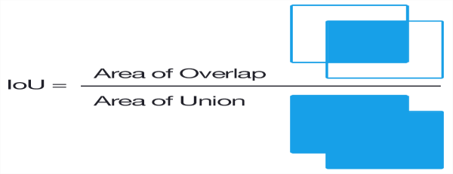

Fig.4.2.8.1. Jaccard similarity co efficient.

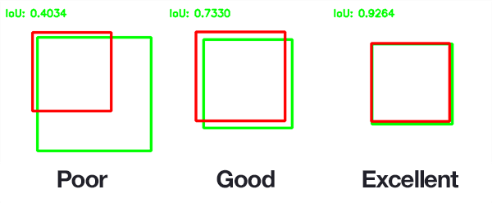

Fig.4.2.8.2. Determining the Quality.

## 4.3 Datasets

### 4.3.1. The Pap Smear Benchmark

The pap-smear database consists of 917 samples distributed unequally on 7 different classes. Each sample is described by 20 features extracted from pictures of single human cells. The data class is a number describing cell type. The pap-smear data set is extracted from sample tissues, taken from the uterine cervix as a part of the smear screening. The purpose of smear screening is to diagnose premalignant cell changes before they progress to cancer.

### 4.3.2. The pap-smear screening

The Papanicolaou Smear method is a medical procedure to detect pre-cancerous cells in the uterine cervix. Using a small brush, cotton-stick or wooden stick, a cytological sample is taken from the cervix and smeared onto a thin glass slide. To clarify the cells characteristics the smear is stained using the Papanicolaou method, so the different components of the cells are emphasized with specific colours - this makes it clearer in a microscope. In general, a stained cell picture contains a nucleus surrounded by cytoplasm on a background as shown in the below figure.

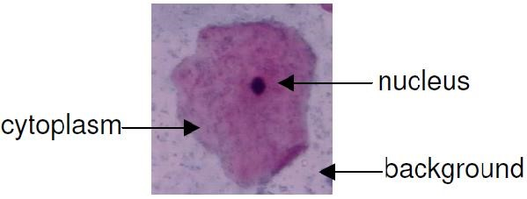

Fig.4.3.2.1. Image of single pap-smear image.

By inspection of the cell characteristics like size, colour, shape and texture of nucleus and cytoplasm, cyto-technicians are capable of diagnosing the cells. Each microscope slide contains up to 300.000 single cells with different orientation and overlap.

In the cervix different kinds of cells exist. They are located in separate areas:

(a) Squamous area

(b) Columnar area

(a)The squamous areas are located in the bottom at the canal of cervix. The cells here lining the cervix are divided into 4 layers: the basal, the para basal, the intermediate and the superficial layer. The youngest cells in the basal layer, lie on the basal membrane. When the cells mature, they move through the layers, and finally, they get ejected from the surface in the superficial layer. Moving through the layers the cells change shape, colour and other characteristics. Cells in the basal layer are small and round, with a large nucleus and a little cytoplasm. Moving through the layers the cytoplasm becomes bigger and the nucleus smaller. The general shape turns more oval, why cells in the superficial layer area are referred to as flat squamous cells.

(b)The columnar area is located in the upper part - and specially in the canal of the cervix. The columnar cells exist only in a single layer - the basal layer.

Characteristics for these cells are a column-like shape with an oblong cytoplasm and a large nucleus located at one end. Somewhere in between these two areas, the cells meet in the squamo-columnar junction. This junction may be located either inside or outside the cervix. The junction is also named the transformation zone because the tall columnar cells are constantly being transformed into flat squamous cells.

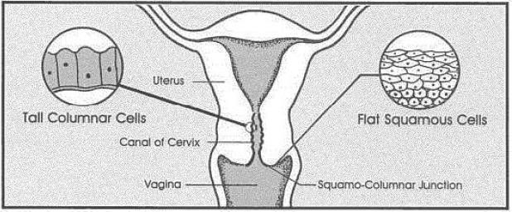

Fig.4.3.2.2. The Uterus in detail and the location of (a) columnarcells and (b) squamouscells.

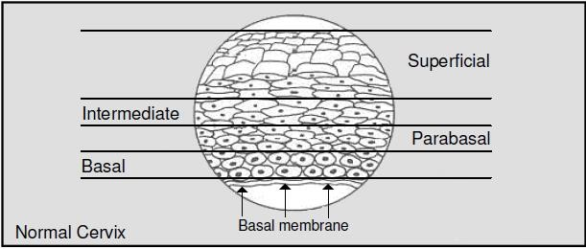

Fig.4.3.2.3. Development of the squamous cells through the four layers.

When the genetic information in a cell is changed, the cell will not divide as it should, it turns into a pre-cancerous cell. In medical terms these are divided into 2 different main diagnoses:

### 4.3.2.1. Dysplasia

The term “dyplasia” means growth, and dysplasia means disordered growth. The cervical dysplasia is normally divided into 3 types: mild, moderate and severe, describing the risk, that the cells turn into malignant cancer cells. Mild means of course lowest risk. The characteristics of cells in dysplasia depends on the kind. In the mild dysplasia they have enlarged and light nucleus. For the moderate dysplasia the nucleus is larger and darker. The nucleus has begun to deteriorate, which is seen as a granulation of the nucleus. In severe dysplasia the nucleus is large, dark and often deformed. The cytoplasm is dark and small, when compared to the nucleus.

#### 4.3.2.2. carcinoma-in-situ

Carcinoma-in-situ means “cancer in place” and is characterized of very large nucleus. In the past, there was a tendency to treat “carcinoma-in-situ” as a much more serious problem than severe dysplasia, when in fact they are essentially the same.

### 4.3.3 The New Pap-Smear Database

The Pap-Smear database is the latest one developed by Herlev University Hospital, the department of Pathology and department of Automation on Technical University of Denmark. The first database was much smaller containing only 500 samples. The set of used features was identical, but the output classes were slightly changed. Classification tasks performed so far, shows more overlap between the classes in the new data set (Martin, 2003). Both data sets are developed for research into automatic classifiers. In this particular data base, the features are extracted by Martin (2003) using MATLAB. The single cell pictures analysed, are prepared by cyto-technicians at Herlev University Hospital using CHAMPsoftware for segmenting the pictures.

### 4.3.4 Data collection

Given a raw large set of glass slides, a database of single pap-smear cells pictures is collected at Herlev University Hospital. Skilled cyto-technicans using a microscope with a resolution of 0.201_m=pixelto grab digital images of the single cells. Each cell image is afterwards manually classified into the 7 different types of cells. For validation the classification is done twice by different cyto-technicians. If the validation is negative the image is discarded. The distribution of the data set are as follows,

### Normal Cells - 242 cells

Superficial squamous epithelial, 74 cells. Intermediate squamous epithelial, 70 cells Columnar epithelial, 98 cells.

### Abnormal Cells- 675 cells

* Mild squamous non-keratinizing dysplasia, 182 cells.
* Moderate squamous non-keratinizing dysplasia, 146 cells.
* Severe squamous non-keratinizing dysplasia, 197 cells.
* Squamous cell carcinoma in situ intermediate, 150 cells.

**4.4 Code Snippets:**

[FileName,PathName]=uigetfile({'*.*','*.bmp,*.jpg'},);

inp=[PathName,FileName];

rgb=imread(inp);

rgb1=double(rgb2gray(inp));

gb=imgaussfilt(rgb1,3);

lg=edge(re,'canny');

bw=bwmorph(lg,'bridge',inf);

[fh]=imfill(bw,'holes');

bw1=bwmorph(fh,'close',inf);

rn=bwareaopen(bw1,1000);

rn1=bwareaopen(dif,150);

imd=bwmorph(rn1,'open');

im2=imdilate(imd,strel('disk',5));

imd1=bwmorph(re,'erode',5);

res=bwareaopen(imd1,3000);

# USER INTERFACE (UI) DESIGN

User interface design (UI) or user interface engineering is the design of user interfaces for machines and software, such as computers, home appliances, mobile devices, and other electronic devices, with the focus on maximizing usability and the user experience. The goal of user interface design is to make the user's interaction as simple and efficient as possible, in terms of accomplishing user goals. A user interface (UI) is a graphical display in one or more windows containing controls, called components that enable a user to perform interactive tasks. The user does not have to create a script or type commands at the command line to accomplish the tasks. Unlike coding programs to accomplish tasks, the user does not need to understand the details of how the tasks are performed.

Good user interface design facilitates finishing the task at hand without drawing unnecessary attention to itself. Graphic design and typography are utilized to support its usability, influencing how the user performs certain interactions and improving the aesthetic appeal of the design; design aesthetics may enhance or detract from the ability of users to use the functions of the interface. The design process must balance technical functionality and visual elements to create a system that is not only operational but also usable and adaptable to changing user needs. UI components can include menus, toolbars, push buttons, radio buttons, list boxes, and sliders—just to name a few. UIs created using MATLAB tools can also perform any type of computation, read and write data files, communicate with other UIs, and display data as tables or as plots.

# CHAPTER 5

# SYSTEM IMPLEMENTATION

Implementation is the carrying out, execution, or practice of a plan, a method, or any design for doing something. It encompasses all the processes involved in getting new software or hardware operating properly in its environment, including installation, configuration, running, testing, and making necessary changes. The word deployment is sometimes used to mean the same thing.

## 5.1. User Interface

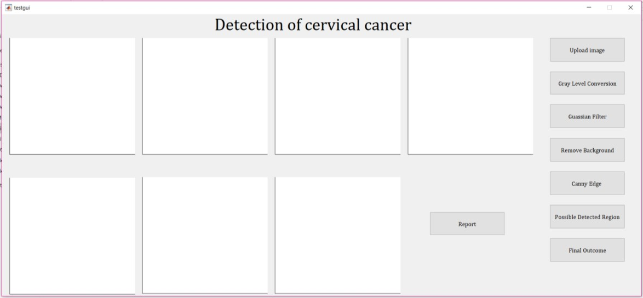

Fig.5.1. User interface

## 5.2. Uploading an Image

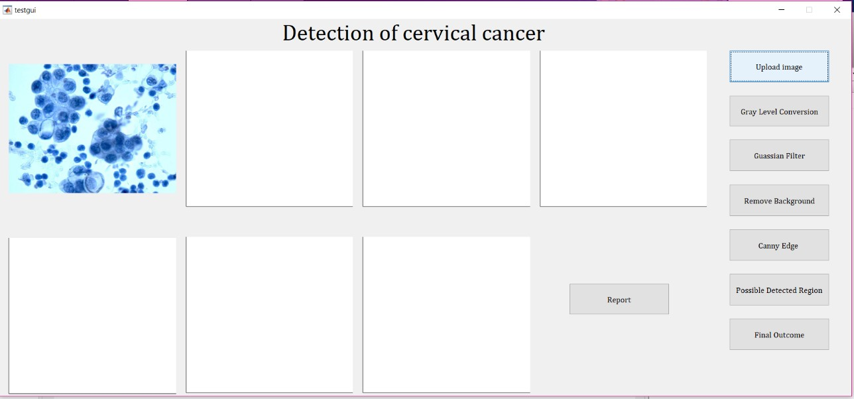

Fig.5.2. Uploading an image.

## 5.3. Gray level conversion

Here we convert the RGB image to gray scale image. In this step 3D image is converted into 2D image.

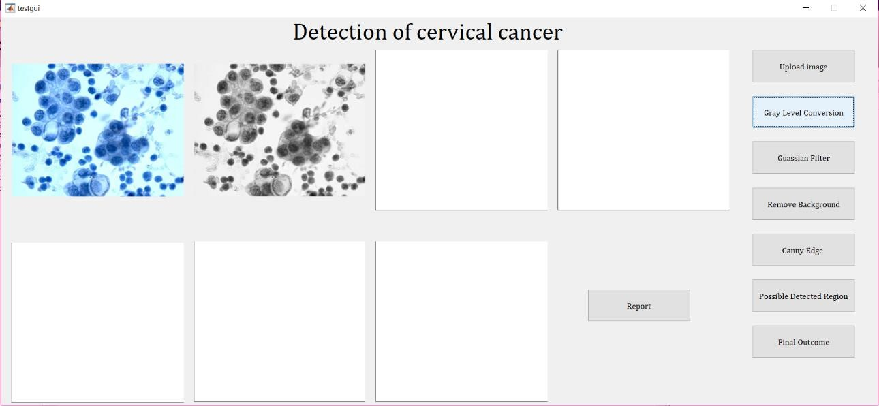

Fig.5.3. Gray scale conversion.

## 5.4. Gaussian filter

In [image processing,](https://en.wikipedia.org/wiki/Image_processing) a Gaussian blur (also known as Gaussian smoothing) is the result of blurring an image by a [Gaussian function.](https://en.wikipedia.org/wiki/Gaussian_function) It is a widely used effect in graphics software, typically to reduce [image noise](https://en.wikipedia.org/wiki/Image_noise) and reduce detail. The visual effect of this blurring technique is a smooth blur resembling that of viewing the [image](https://en.wikipedia.org/wiki/Image) through a translucent screen, distinctly different from the [bokeh](https://en.wikipedia.org/wiki/Bokeh) effect produced by an out-of-focus lens or the shadow of an object under usual illumination. In this project Gaussian filter is applied to decrease the gap of affected cells. This filter smoothen the given image.

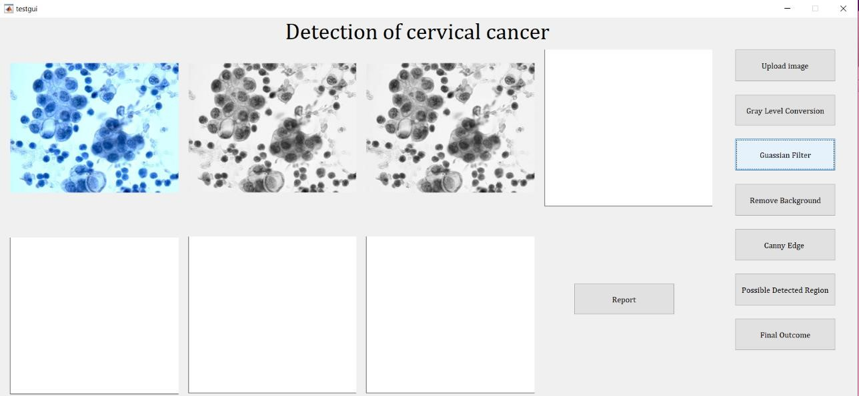

Fig.5.4. Gaussian filter.

## 5.5. Grouping affected cells

Adaptive thresholding is an image segmentation algorithm that appears quite resistant to varying lighting conditions. The most basic thresholding method is to choose a fixed threshold value and compare each pixel to that value.

The affected cells will be retained by using adaptive threshold technique. The maximum intensity values of smoothen image is considered as background.

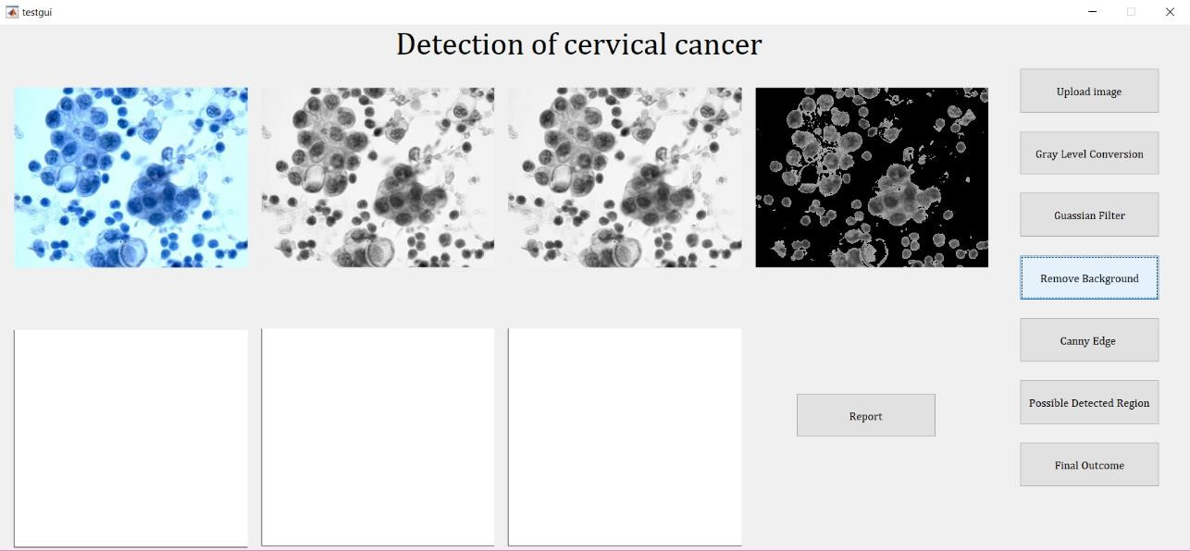

Fig.5.5. Grouping affected cells.

## 5.6. Edge Technique

The Canny edge technique is used to extract the abrupt changes of affected cells and non- affected cells. This technique help us to make the difference between affected and nonaffected cells.

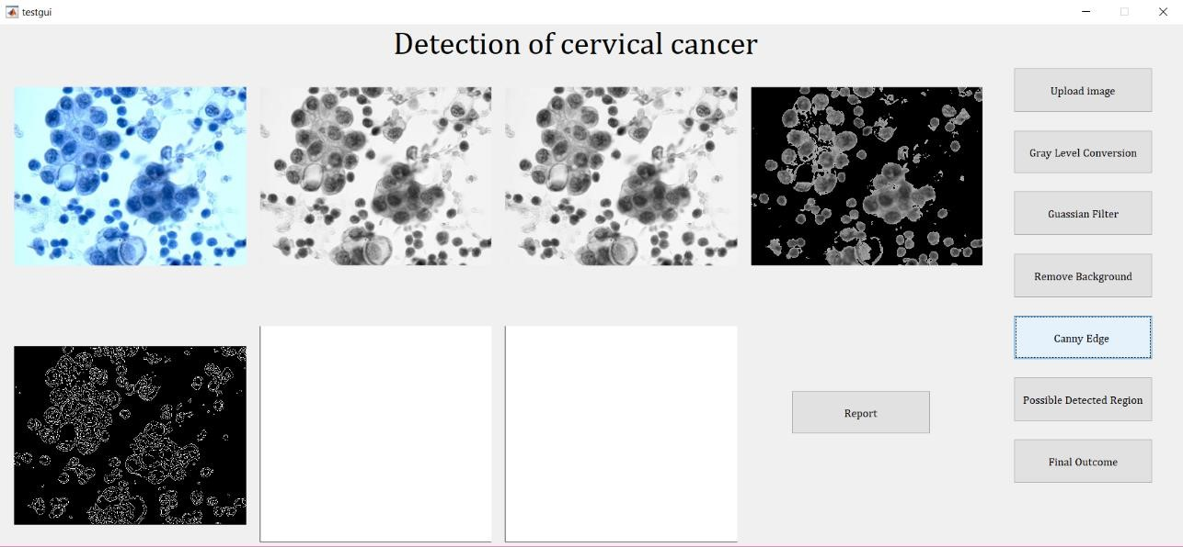

Fig.5.6. Edge Technique.

## 5.7. Extraction of Holes

Where, affected cells form large sized holes and non-affected cells form small sized holes. Some of the cells could not generate the holes, at that time bridge morphological function is used to generate the holes.

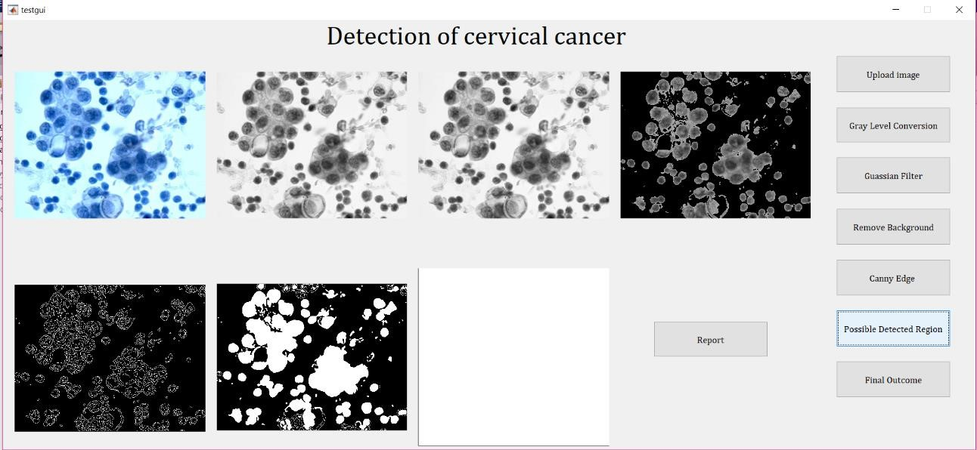

Fig.5.7. Extraction of Holes.

## 5.8. Extraction of affected cells

The larger components are considered as affected cells. To retain this larger components, the morphological functions are used effectively.

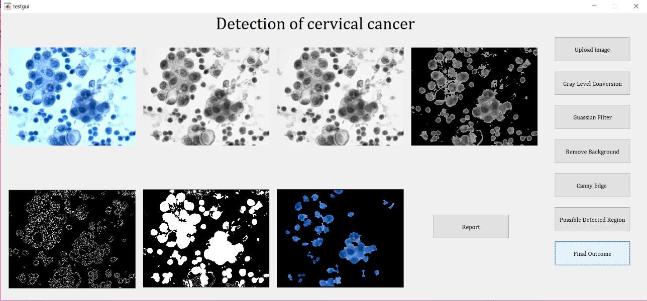

Fig.5.8. Extraction of affected cells.

## 5.9. Accuracy displaying in percentage

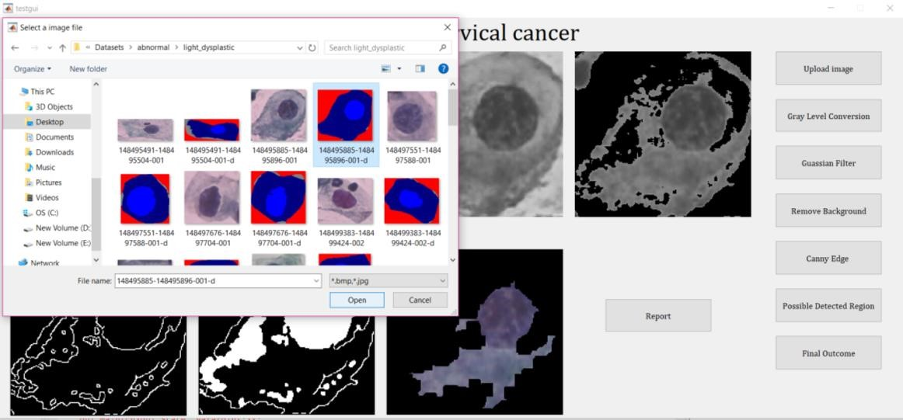

Fig.5.9.1. Detecting accuracy by using ground truth image for cervical cell.

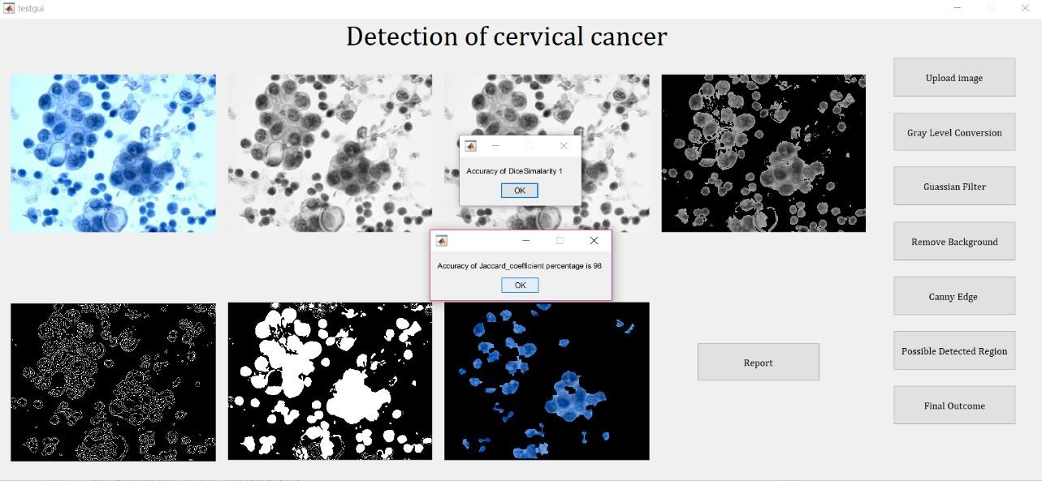

Fig. 5.9.2. Displaying Accuracy.

# CHAPTER 6

# SYSTEM TESTING

Software testing is a process of executing a program or application with the intent of finding the software bugs. It can also be stated as the process of validating and verifying that a software program or application or product meets the business and technical requirements that guided its design and development. The purpose of testing can be quality assurance, verification and validation, or reliability estimation. Testing can be used as a generic metric as well. Correctness testing and reliability testing are two major areas of testing. Software testing is a trade-off between budget, time and quality.

**6.1. What is Verification and Validation?**

Verification is the process to make sure the product satisfies the conditions imposed at the start of the development phase. In other words, to make sure the product behaves the way we want it to. Validation is the process to make sure the product satisfies the specified requirements at the end of the development phase. In other words, to make sure the product is built as per customer requirements.

## 6.2. Key Benefits of Testing

The key benefits of testing are

* Reduced risk of failures (or incidents) once systems are transferred to live operation
* Demonstrative proof that business requirements have been met
* Assurance that the system will function appropriately with existing legacy systems where required and will integrate with other systems as necessary
* Assurance that the users for which the solution was designed are able to operate productively

Acknowledging these benefits requires accepting the reality that testing costs money. Too much testing could be risky, as it may delay product launch and allow a competitor to steal significant market share. Unfocused, inefficient approaches to test management often result in poor return on investment in testing. As a rule of thumb, sufficient testing is where the costs of testing can be balanced against the potential costs of failures and over run. The risks of failure and business benefit should be used to determine how much testing is performed.

## 6.3. Basics of Testing

There are two basics of software testing: Blackbox testing and Whitebox testing.

### 6.3.1. Behavioural testing

Behavioural or Black-box testing is a method of software testing that examines the functionality of an application without peering into its internal structures or workings. This method of test can be applied to virtually every level of software testing: unit, integration, system and acceptance.

### 6.3.2. Structural Testing

Structural or White box testing is a testing technique that examines the program structure and derives test data from the program logic/code. The other names of glass box testing are clear box testing, open box testing, logic driven testing or path driven testing or structural testing.

## 6.4. Types of Testing

Testing is the process where we validate and verify if the product meets the user’s requirements and adheres to the specification. There are several types of testing processes available.

* Unit Testing
* Integration Testing
* Functional Testing
* System Testing
* Stress Testing
* Performance Testing
* Usability Testing
* Acceptance Testing
* Regression Testing

* Beta Testing

### 6.4.1. Unit Testing

Unit testing is the testing of an individual unit or group of related units. It falls under the class of white box testing. It is often done by the programmer to test that the unit he/she has implemented is producing expected output against given input.

### 6.4.2. Integration Testing

Integration testing is testing in which a group of components are combined to produce output. Also, the interaction between software and hardware is tested in integration testing if software and hardware components have any relation. It may fall under both white box testing and black box testing.

### 6.4.3. Functional Testing

Functional testing is the testing to ensure that the specified functionality required in the system requirements works. It falls under the class of black box testing.

### 6.4.4. System Testing

System testing is the testing to ensure that by putting the software in different environments (e.g., Operating Systems) it still works. System testing is done with full system implementation and environment. It falls under the class of black box testing.

### 6.4.5. Stress Testing

Stress testing is the testing to evaluate how system behaves under unfavourable conditions. Testing is conducted at beyond limits of the specifications. It falls under the class of black box testing.

### 6.4.6. Performance Testing

Performance testing is the testing to assess the speed and effectiveness of the system and to make sure it is generating results within a specified time as in performance requirements. It falls under the class of black box testing.

### 6.4.7. Usability Testing

Usability testing is performed to the perspective of the client, to evaluate how userfriendly the GUI is? How easily can the end users learn? After learning how to use, how proficiently can the users perform? How pleasing is it to use its design? This falls under the class of black box testing.

### 6.4.8. Acceptance Testing

Acceptance testing is often done by the customer to ensure that the delivered product meets the requirements and works as the customer expected. It falls under the class of black box testing.

### 6.4.9. Regression Testing

Regression testing is the testing after modification of a system, component, or a group of related units to ensure that the modification is working correctly and is not damaging or imposing other modules to produce unexpected results. It falls under the class of black box testing.

### 6.4.10. Beta Testing

Beta testing is the testing which is done by end users, a team outside development, or publicly releasing full pre-version of the product which is known as beta version. The aim of beta testing is to cover unexpected errors. It falls under the class of black box testing.

## 6.5. Manual and Automation Testing

### 6.5.1. Manual Testing

Manual testing includes testing a software manually, i.e., without using any automated tool or any script. In this type, the tester takes over the role of an end-user and tests the software to identify any unexpected behaviour or bug. There are different stages for manual testing such as unit testing, integration testing, system testing, and user acceptance testing.

Testers use test plans, test cases, or test scenarios to test a software to ensure the completeness of testing. Manual testing also includes exploratory testing, as testers explore the software to identify errors in it.

### 6.5.2. Automation Testing

Automation testing, which is also known as Test Automation, is when the tester writes scripts and uses another software to test the product. This process involves automation of a manual process. Automation Testing is used to re-run the test scenarios that were performed manually, quickly, and repeatedly.

Apart from regression testing, automation testing is also used to test the application from load, performance, and stress point of view. It increases the test coverage, improves accuracy, and saves time and money in comparison to manual testing.

## 6.6. Test Cases

A test case is a set of conditions or variables under which a tester will determine whether a system under test satisfies requirements or works correctly. The process of developing test cases can also help find problems in the requirements or design of an application.

Writing good test cases involve the following steps —

* Test cases should be ‘atomic’; they should not overlap or complicate testing. Each test case should be written such that only one thing should be tested at a time
* All positive and negative scenarios should be considered
* Each test case should be written in a language that is simple and easy to understand, using an active voice, and using consistent and exact names

The characteristics of a good test case are —

* Accurate
* Economical
* Traceable
* Repeatable
* Reusable

**6.6.1. Test Results:**

All the test cases mentioned above passed successfully. No defects encountered.

|  |  |  |  |  |
| --- | --- | --- | --- | --- |
| **Test case No.** | **Input** | **Expected output** | **Actual output** | **Status**  **(Pass/Fail)** |
| **1.** | Uploading of  Image | Image accepted by system | Image uploaded  successfully | Pass |
| **2.** | Gray level  Conversion | Whole input image converted to grayscale  image | Gray scale image | Pass |
| **3.** | Applying Gaussian  Filtration | Gaussian filter processed Images are displayed | Gaussian filter processed Images are displayed | Pass |
| **4.** | Removal of  background | Highlight the  region | Highlight the  region | Pass |
| **5.** | Canny edge  Processing | Find edges in  intensity image | Detect edges in  intensity image | Pass |
| **6.** | Morphological functions | Openperforms morphological closing  operation | Close performs morphological closing operation using Dialation | Pass |
| **7.** | Morphological functions | Close performs morphological closing operation | Closeperforms morphological closing operation using erosion | Pass |
| **8.** | Possible detected region | Detect the  cancerous cells | Detect the  cancerous cells | Pass |
| **9.** | Finding accuracy of the cancerous cells prediction | Accuracy inpercentage using Jaccard similarity co efficient | Accuracy calculated successfully | Pass |

Table:6.6.1. Test detection of cervical cancer System

# CHAPTER 7

# CONCLUSION

Cervical cancers are screened manually by using the Pap smear test and LCB take a look at which does not deliver correct classification results in classifying the regular and unusual cervical cells in the cervix location of the uterus. The manually screened technique suffers from high fake price due to human errors and also cost effective to be achieved by using the skilled cytologist. In this paper, a method is achieved for the automated detection of cervical cancer using image processing techniques. The automated techniques are done to supply correct outcomes and to make powerful classification of normal and abnormal cells.

# CHAPTER 8

# REFERENCE

Cytoplasm and nucleus segmentation in cervical smear images using Radiating GVF Snake by Kuan Li, Zhi Lu, Wenyin Liu, Jianping Yin, 2011.

Detection of Cervical Cancer by Using Thresholding & Watershed Segmentation by Setu Garg, Shabana Urooj, Ritu Vijay, 2015.

Automated Cervical Cancer Detection using Photonic Crystal based Bio-Sensor by Nithin S, Poonam Sharma, Vivek M, PreetaSharan, 2015.

Cervical Cancer Detection from MR Images based on multi resolution wavelet analysis by Shipra Roy, R.P Chauhan, G.K. Verma, 2016.

Detection of Cervical Cancer using the Image Classification Algorithms by M. Anousouya Devi, S. Ravi,J. Vaishnavi S. Punitha, 2016.

Cervical Cancer Screening and Classification Using Acoustic Shadowing by N.SakthiPriya, Assistant Professor, Dept of CSE, Bharath University, Chennai, TamilNadu, India, 2013.

Automated Cervical Cancer Detection through RGVF segmentation and SVM Classification by Sajeena TA, Jereesh A S, 2015.

Seeded Region Growing Features Extraction Algorithm; Its Potential Use in Improving Screening for Cervical Cancer by N.A. Mat-Isa, M.Y. Mashor, N.H. Othman, 2005.